- Git is a software installed on your local machine for Code Check-in and Check-out, whereas, GitHub is a Distributed Version Control System (VCS) that controls the latest version of your code. Hence, with the help of GIT installation, we will create a local repository of our Maven Project and with the help of GITHub web portal, we will create a public repository for real-time version control.
To install Git on your local machine, go to website: https://git-scm.com/install/windows and download the latest version of the software. 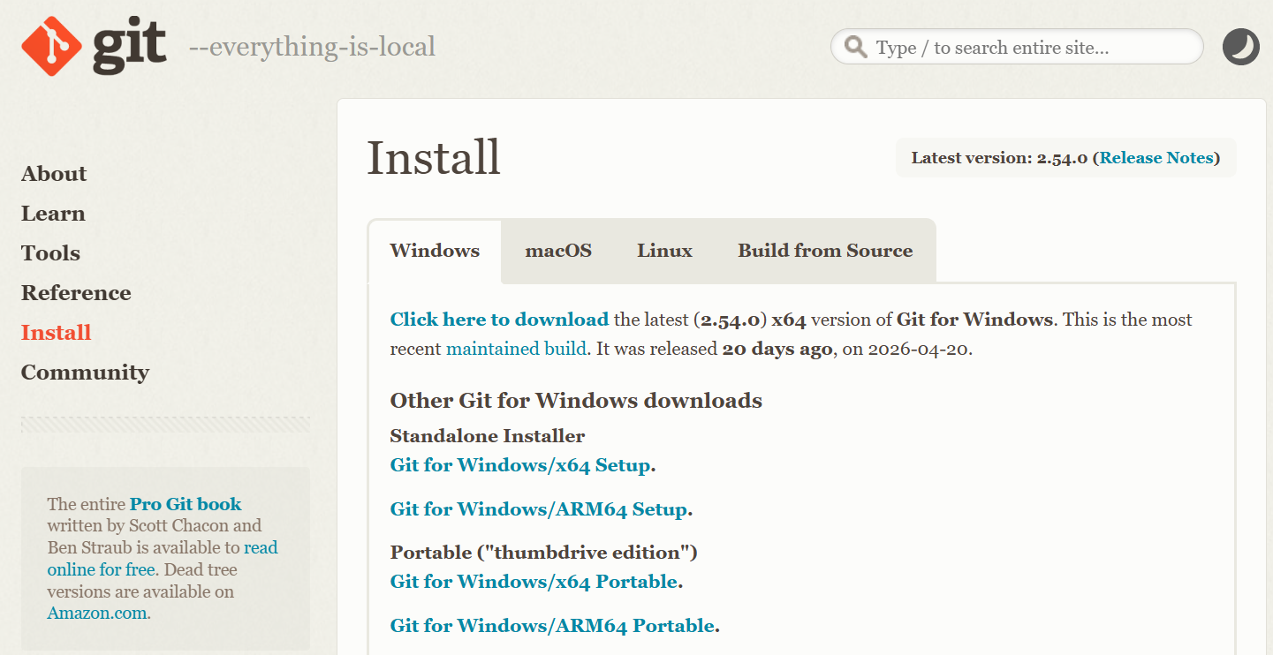

- Now select the PATH environment to use GIT from Command Prompt or from GIT Bash. Choose recommended option to avoid further complications and click on Next.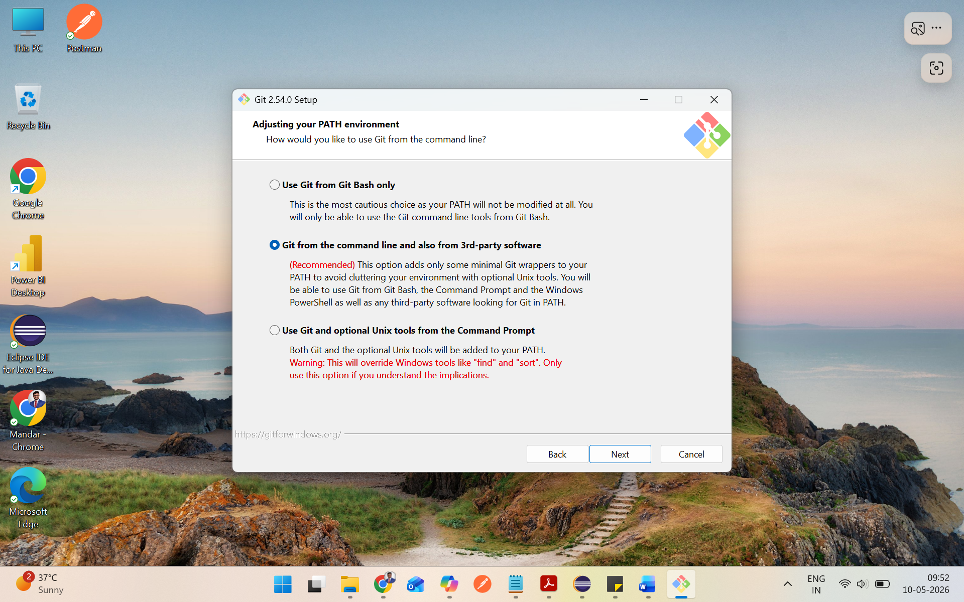

- Launch GIT Bash and finish the installations: 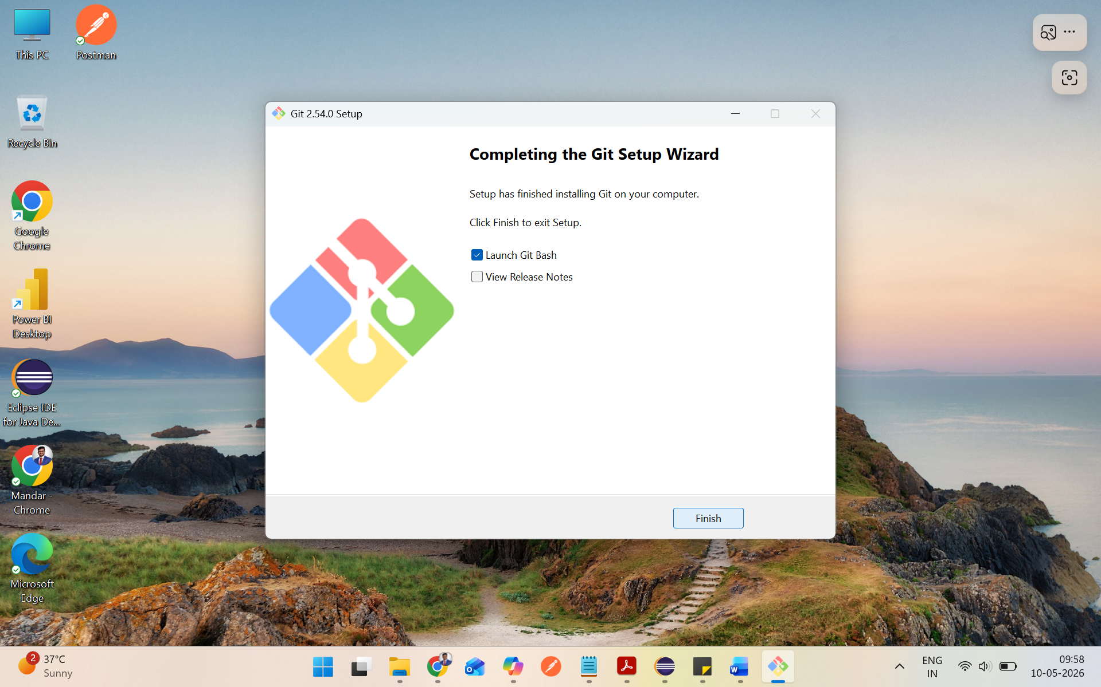

- After GIT is successfully installed and your Selenium/REST-Assured API Testing Code is ready with all the Maven dependencies such as Selenium-Java, TestNG and ExtentReports, you need to first build the code with Maven.
Right Click on POM.xml File and click on Run As > Maven test.
You should see the BUILD SUCCESS status in the console.
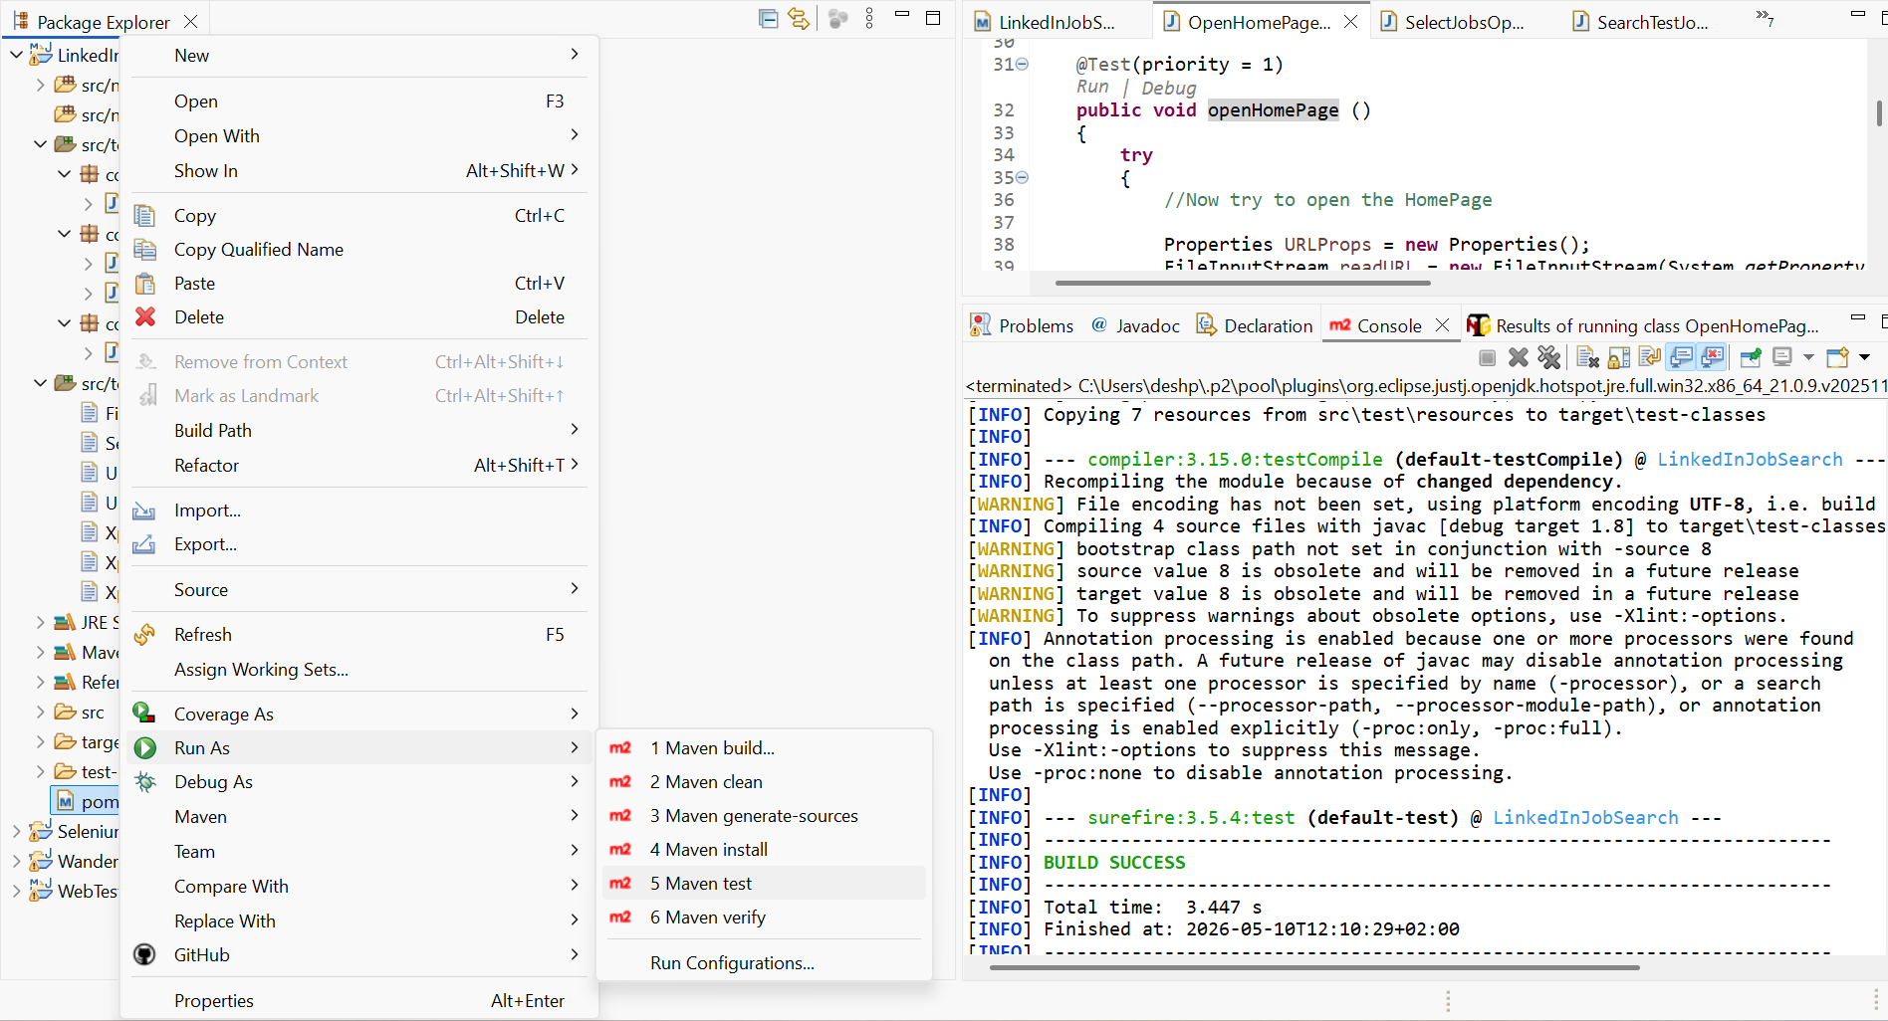

- Now login to GitHub Dashboard with your own Gmail account. https://github.com/dashboard and we will create a public repository. 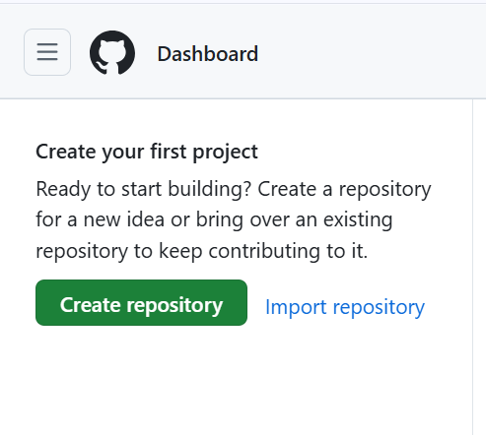

- Here enter your repository name. I have kept Repository name same as that of Maven Project Name same from Eclipse and added the small description.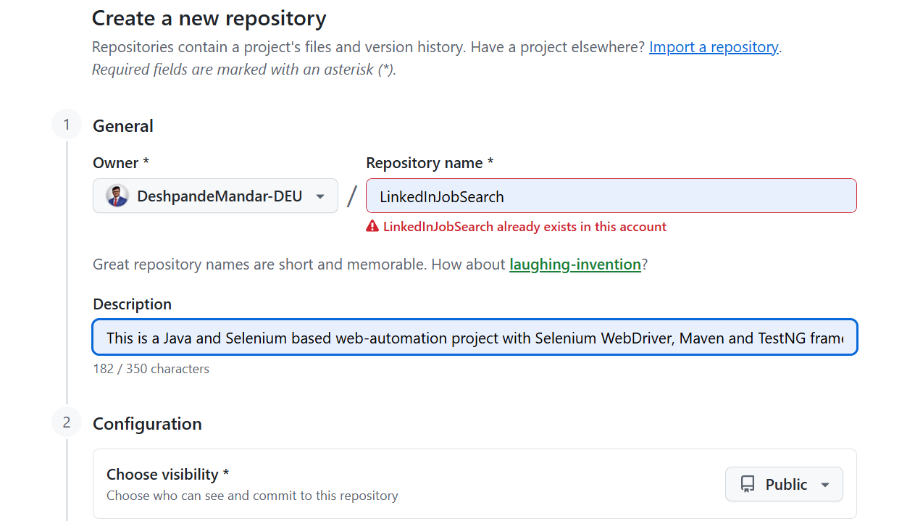
- The basics are done! Now open GitBash which we installed in first place and create a public private ShellScript key to secure your online project from intrusions. To setup a secure connection, enter the command: $ ssh-keygen -t rsa and hit Enter button 3 times. I have not set any passphrase; I just kept it empty. 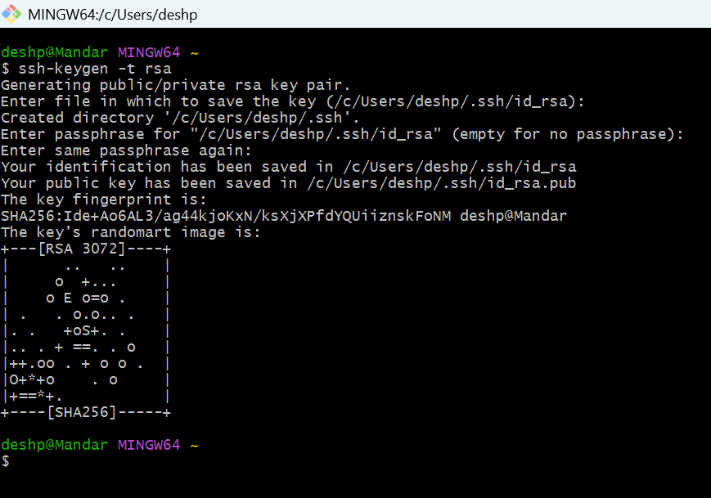

- It will generate one private and one public SSH Keys at above mentioned location. 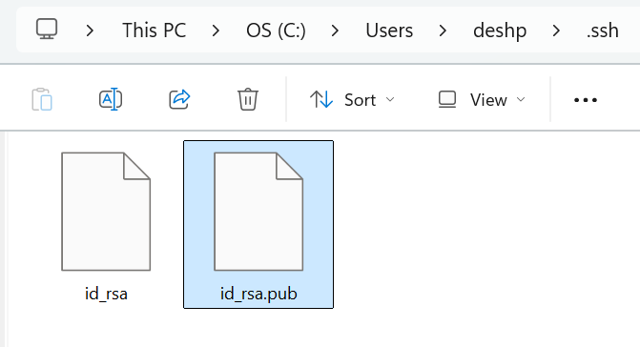

- Now go to your GitHub Profile > Settings > SSH and GPG Keys option and click on New SSH key.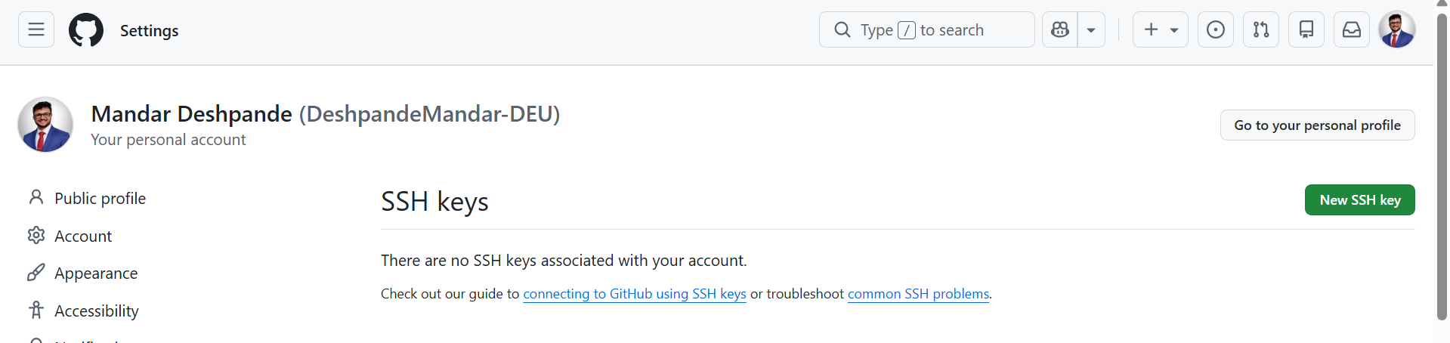

- Copy the contents of Public Key from previously generated files and paste it in the box and click on Add SSH key.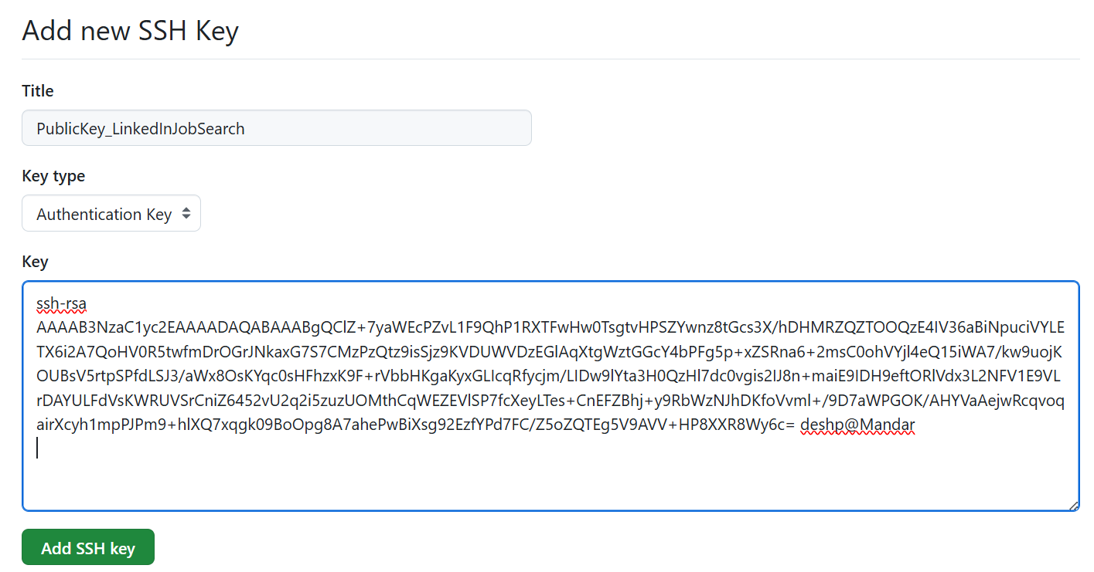

- It will ask you for the password. Confirm it.
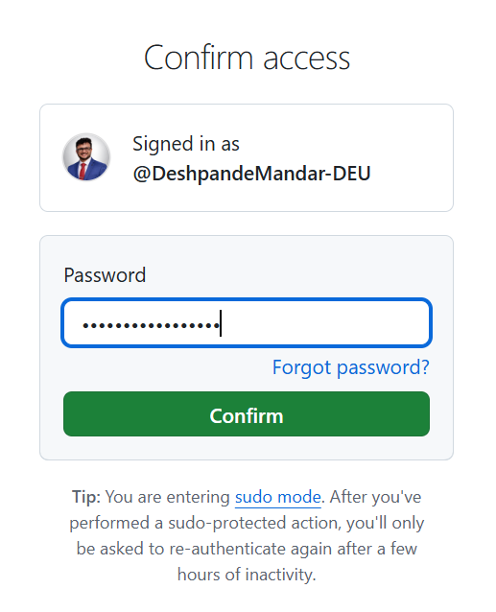

- Your Public Key is visible in your Profile. Follow same procedure for the Private Key.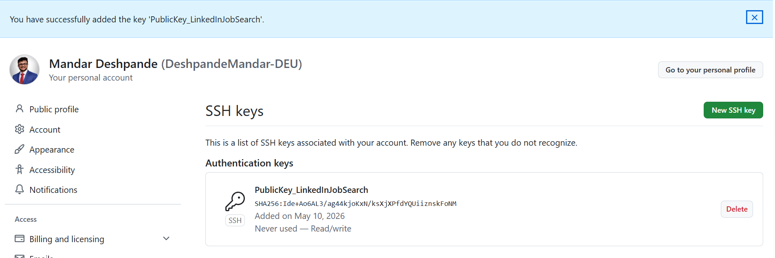

- Now, again back to Basics, we have to Open GitBash from our actual Maven Project and first have to create a local repository. 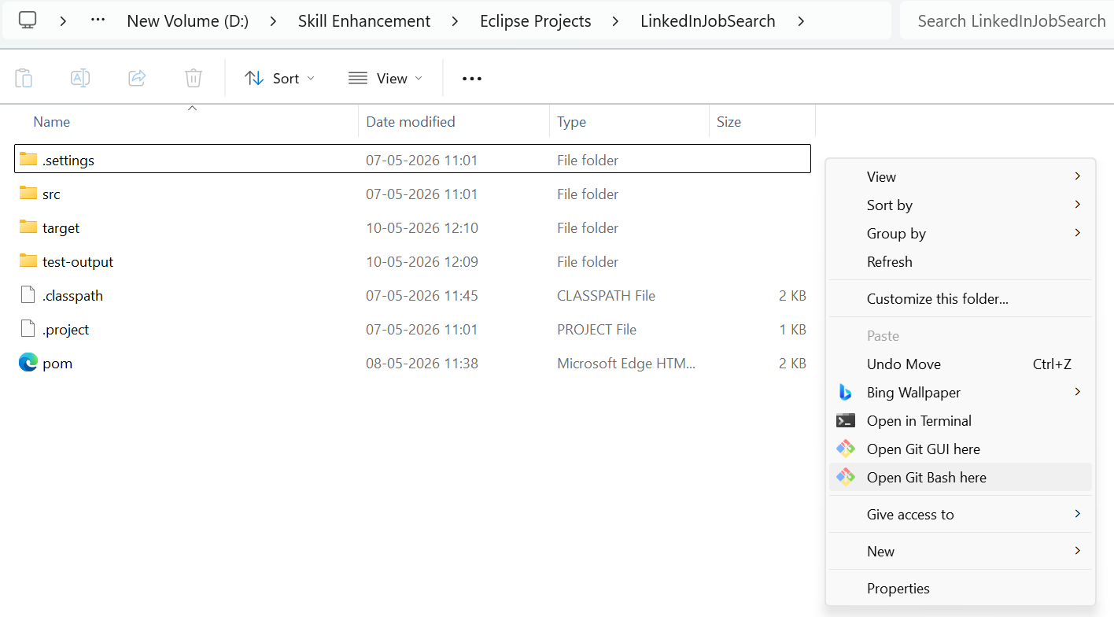

- Now we have to initialize the local git repository with the command:
deshp@Mandar MINGW64 /d/Skill Enhancement/Eclipse Projects/LinkedInJobSearch
$ ls
pom.xml src/ target/ test-output/

deshp@Mandar MINGW64 /d/Skill Enhancement/Eclipse Projects/LinkedInJobSearch
$ git init
Initialized empty Git repository in D:/Skill Enhancement/Eclipse Projects/LinkedInJobSearch/.git/
This will generate a hidden .git folder in the same project. 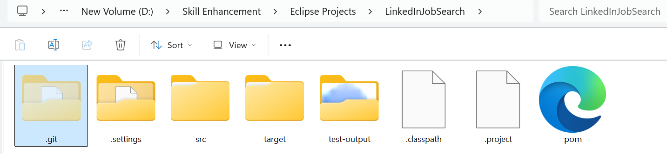
- You can check the status for which files can be tracked to GIT.
deshp@Mandar MINGW64 /d/Skill Enhancement/Eclipse Projects/LinkedInJobSearch (master)
$ git status
On branch master

No commits yet

Untracked files:
(use "git add <file>..." to include in what will be committed)
.classpath
.project
.settings/
pom.xml
src/
target/
test-output/

nothing added to commit but untracked files present (use "git add" to track)

- Now add files one by one with the $ git add command and check the status once again. deshp@Mandar MINGW64 /d/Skill Enhancement/Eclipse Projects/LinkedInJobSearch (ma
ster)
$ git add pom.xml

deshp@Mandar MINGW64 /d/Skill Enhancement/Eclipse Projects/LinkedInJobSearch (master)
$ git add src/

deshp@Mandar MINGW64 /d/Skill Enhancement/Eclipse Projects/LinkedInJobSearch (master)
$ git add test-output/

deshp@Mandar MINGW64 /d/Skill Enhancement/Eclipse Projects/LinkedInJobSearch (master)
$ git status
On branch master

No commits yet

Changes to be committed:
(use "git rm --cached <file>..." to unstage)
new file: pom.xml
new file: src/main/java/com/PoJos/DateFormater.java
new file: src/test/java/com/DriverSetup/ChromeDriverSetup.java
new file: src/test/java/com/HomePage/OpenHomePageAndLogin.java
new file: src/test/java/com/HomePage/SelectJobsOption.java
new file: src/test/java/com/JobPage/SearchTestJobsInGermany.java
new file: src/test/resources/FilePaths.properties
new file: src/test/resources/SearchKeys.properties
new file: src/test/resources/URLs.properties
new file: src/test/resources/UserCredentials.properties
new file: src/test/resources/XpathsFeedPage.properties
new file: src/test/resources/XpathsJobsPage.properties
new file: src/test/resources/XpathsLoginPage.properties
new file: test-output/Default suite/Default test.html
new file: test-output/Default suite/Default test.xml
new file: test-output/Default suite/testng-failed.xml
new file: test-output/bullet_point.png
new file: test-output/collapseall.gif
new file: test-output/emailable-report.html
new file: test-output/failed.png
new file: test-output/index.html
new file: test-output/jquery-3.6.0.min.js
new file: test-output/junitreports/TEST-com.HomePage.OpenHomePageAndLogin.xml
new file: test-output/navigator-bullet.png
new file: test-output/passed.png
new file: test-output/skipped.png
new file: test-output/testng-failed.xml
new file: test-output/testng-reports.css
new file: test-output/testng-reports.js
new file: test-output/testng-reports1.css
new file: test-output/testng-reports2.js
new file: test-output/testng-results.xml

Untracked files:
(use "git add <file>..." to include in what will be committed)
.classpath
.project
.settings/
target/

- Before commit, Git will ask you for your email address. Give it with below command: deshp@Mandar MINGW64 /d/Skill Enhancement/Eclipse Projects/LinkedInJobSearch (master)
$ git config --global user.email "deshpande.mandar7@gmail.com"
or with git config --global user.name "Your Name"

- Now commit the files those are already tracked with $add command.
deshp@Mandar MINGW64 /d/Skill Enhancement/Eclipse Projects/LinkedInJobSearch (master)
$ git commit -m "My first commit"
[master (root-commit) e3ed1bd] My first commit
32 files changed, 1976 insertions(+)
create mode 100644 pom.xml
create mode 100644 src/main/java/com/PoJos/DateFormater.java
create mode 100644 src/test/java/com/DriverSetup/ChromeDriverSetup.java
create mode 100644 src/test/java/com/HomePage/OpenHomePageAndLogin.java
create mode 100644 src/test/java/com/HomePage/SelectJobsOption.java
create mode 100644 src/test/java/com/JobPage/SearchTestJobsInGermany.java
create mode 100644 src/test/resources/FilePaths.properties
create mode 100644 src/test/resources/SearchKeys.properties
create mode 100644 src/test/resources/URLs.properties
create mode 100644 src/test/resources/UserCredentials.properties
create mode 100644 src/test/resources/XpathsFeedPage.properties
create mode 100644 src/test/resources/XpathsJobsPage.properties
create mode 100644 src/test/resources/XpathsLoginPage.properties
create mode 100644 test-output/Default suite/Default test.html
create mode 100644 test-output/Default suite/Default test.xml
create mode 100644 test-output/Default suite/testng-failed.xml
create mode 100644 test-output/bullet_point.png
create mode 100644 test-output/collapseall.gif
create mode 100644 test-output/emailable-report.html
create mode 100644 test-output/failed.png
create mode 100644 test-output/index.html
create mode 100644 test-output/jquery-3.6.0.min.js
create mode 100644 test-output/junitreports/TEST-com.HomePage.OpenHomePageAndLogin.xml
create mode 100644 test-output/navigator-bullet.png
create mode 100644 test-output/passed.png
create mode 100644 test-output/skipped.png
create mode 100644 test-output/testng-failed.xml
create mode 100644 test-output/testng-reports.css
create mode 100644 test-output/testng-reports.js
create mode 100644 test-output/testng-reports1.css
create mode 100644 test-output/testng-reports2.js
create mode 100644 test-output/testng-results.xml

- Now we have to upload this local repository with the public distributed repository. Go to GITHub Dashboard and to your Project. Click on green button named as < > Code. Go to SSH option and copy the URL to clipboard. 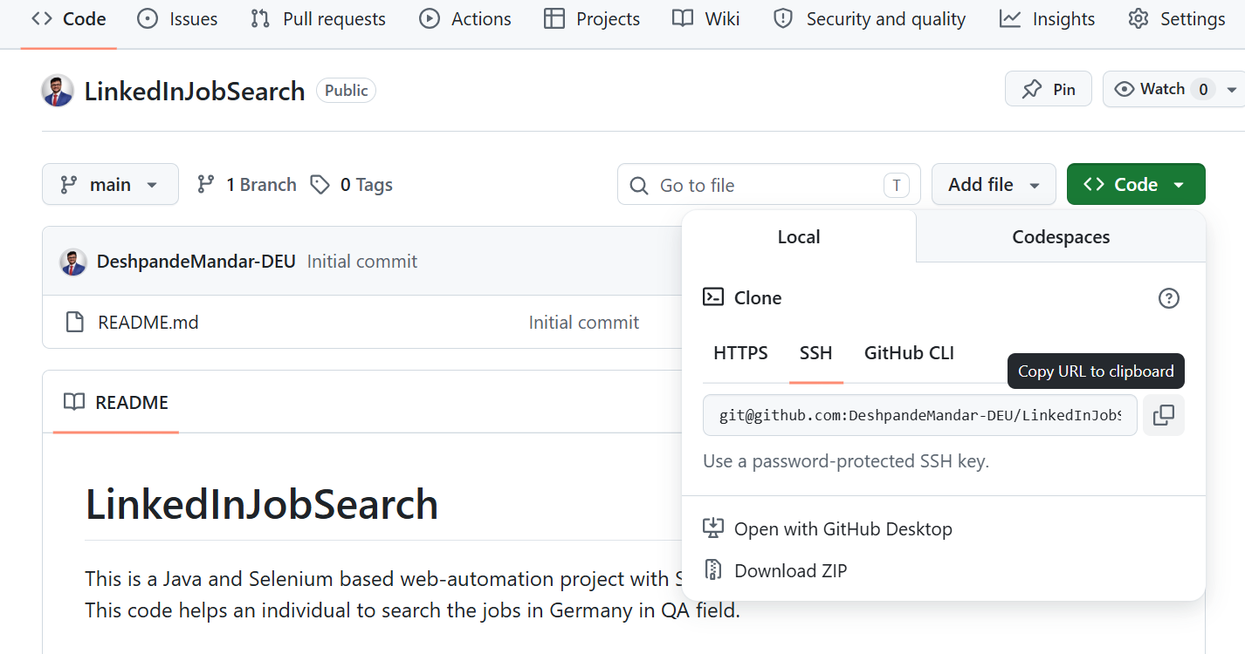

- Finally add the remote connection and push your code to Distributed VCS which is GITHub.
deshp@Mandar MINGW64 /d/Skill Enhancement/Eclipse Projects/LinkedInJobSearch (master)
$ git remote add origin git@github.com:DeshpandeMandar-DEU/LinkedInJobSearch.git

deshp@Mandar MINGW64 /d/Skill Enhancement/Eclipse Projects/LinkedInJobSearch (master)
$ git push -u origin master

The results will look like this:

Warning: Permanently added 'github.com' (ED25519) to the list of known hosts.
Enumerating objects: 48, done.
Counting objects: 100% (48/48), done.
Delta compression using up to 8 threads
Compressing objects: 100% (41/41), done.
Writing objects: 100% (48/48), 50.58 KiB | 1015.00 KiB/s, done.
Total 48 (delta 7), reused 0 (delta 0), pack-reused 0 (from 0)
remote: Resolving deltas: 100% (7/7), done.
remote:
remote: Create a pull request for 'master' on GitHub by visiting:
remote: https://github.com/DeshpandeMandar-DEU/LinkedInJobSearch/pull/new/master
remote:
To github.com:DeshpandeMandar-DEU/LinkedInJobSearch.git
* [new branch] master -> master
branch 'master' set up to track 'origin/master'.

- Now check whether your commit and push are working fine on GITHub. If everything is successfully pushed, you will see the code folders, pom.xml file is added to your online project. 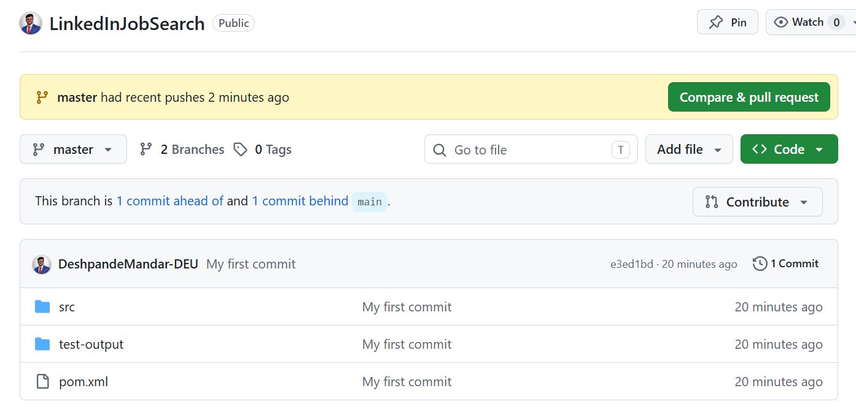
- To remove the lock, use the below command: rm -f ./.git/index.lock

